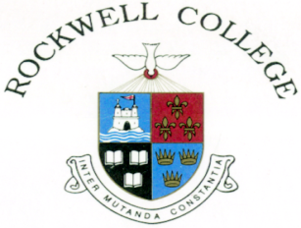
FEES 2027 - 2028
Day Boarders: €7,782
This fee includes tuition, lunch, tea, extra-curricular and recreational facilities, supervised Evening Study, the cost of in-school nursing care, photocopying, postage, administration, 24-hour accident insurance cover, retreats & team buses.

25% Discount for second and subsequent siblings as per the conditions as detailed in the Fee Policy

A deposit of €500 is payable on final confirmation of your place in the College. This amount is refunded to you when your child leaves the College, usually by September, provided that all charges have been paid in full. The Fees invoice will issue to you annually in late June, other fees will be charged to your account as they arise.
In the event of cancellation the deposit is non-refundable.

Please ensure you quote your Account Reference OR child’s name on all bank transfers to the Rockwell College account. Your Account Reference will be shown on your invoice / statement from the College.

Additional Costs
Uniform: Available at Helen’s Kidswear Thurles Ph: (0504) 58937, Email: helensuniforms@gmail.com
Sports Gear: Available to purchase on-line at www.uniformity.ie
Class books: A list of required schoolbooks is available in June on our website www.rockwellcollege.ie
Transition Year: Estimate of additional costs relating to excursions and activities is €1,500 approx.
The cost of any non-mandatory trips outside of Ireland are not included in this estimate.
Exam charges: State Examination charges and Mock exam correction charges.
Medical Care: Any medical or transport costs that may occur related to medical care will be charged to Parents/Guardian.

Payment Details for Day Students in Rockwell College
Single Payment: Due on or before August 1st, 2027
Two half-year payments: Due August 1st, 2027 & November 1st, 2027
Standing Order: Ten monthly payments commencing August 1st, 2027

Standing Order option can be setup on electronic banking and inform accounts@rockwellcollege.ie of same. Payments must commence on 1st August annually and continue over 10 consecutive months up to and including 1st May annually.

All fees can be paid directly to the following account:
- Name: Rockwell House Account
- IBAN Code IE92AIBK93506920687039
- Swift Code AIBKIE2D
- Allied Irish Bank, Main Street, Cashel, Co. Tipperary, Ireland.

Please ensure you quote your Account Reference OR your child’s name on all bank transfers to the Rockwell College account. Your Account Reference will be shown on your invoice/statement from the College.

